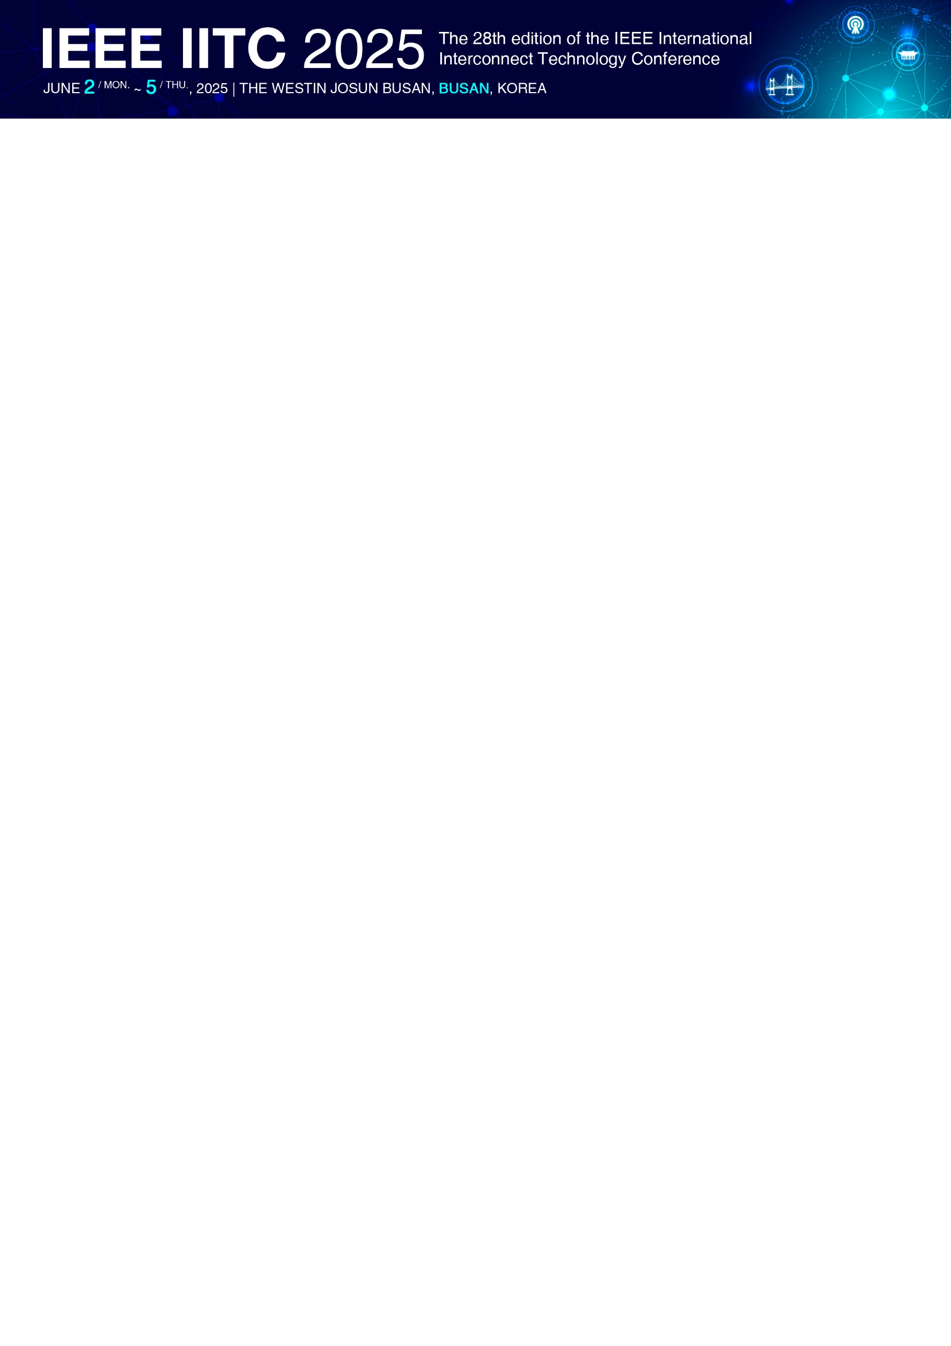**Sponsorship Application Form**

|  |  |  |  |
| --- | --- | --- | --- |
| **A. Company Information** | | | |
| **Company Name** |  | | |
| **Address** |  | | |
| **Website** |  | | |
| **President** |  | | |
| **Contact Person Name** |  | **Job Title/ Department** |  |
| **Telephone** |  | **Mobile** |  |
| **E-mail** |  | | |
| **B. Sponsorship Application (Please check(V) for your choice) *USD 1 = KRW 1,450** | | | |
| |  |  |  | | --- | --- | --- | | **Category** | □ Platinum | **USD 15,000 / KRW 21,750,000** | | □ Gold | **USD 8,000 / KRW 11,600,000** | | □ Silver | **USD 6,000 / KRW 8,700,000** | | □ Bronze | **USD 3,000 / KRW 4,350,000** | | **C. Payment Method (Wire Transfer Only)** | | | | **\*Only for domestic**  **◾ Account Holder:** The Korean Institute of Electrical and Electronic Material Engineers (KIEEME)  **◾ Account Number:** 0602-0605-2025  **◾ Bank Name:** SUHYUP BANK  **◾ SWIFT Code:** NFFCKRSE  **◾ Bank Address:** 22 Teheran-ro 7-gil, Gangnam-gu, Seoul, South Korea | | | | **\*Only for overseas**  **◾ Account Holder:** The Korean Institute of Electrical and Electronic Material Engineers (KIEEME)  **◾ Account Number:** 1800-0066-9680  **◾ Bank Name:** SUHYUP BANK  **◾ SWIFT Code:** NFFCKRSEXXX  **◾ Bank Address:** The Korean federation of Science and Technology Branch. 22, Teheran-ro 7-gil, Gangnam-gu, Seoul, Republic of Korea. | | | | **◾ Sponsorship Application Deadline: April 11, 2025** | | | | ◾ Please fill out and fax or e-mail the Sponsorship Application form to the IEEE IITC 2025 Secretariat **with a copy of business registration certificate.** | | | | | | |

**Name of Applicant: Date:**

**Signature:**

**IEEE IITC 2025 Secretariat**   
Tel: 042-472-7460  
E-mail: info@iitc2025.org