Please complete the form and send it to reservation@westinjosun.com or 051-749-7001

1. Personal Information
Mr. | Ms. | *First Name |  |  |  |  | *Last Name
☐ | ☐
Conference Name  (Company Name) |  | IEEE IITC 2025 (2025.1st June (Sun)- 5th June (Thu))
* Nationality(Country) |  |  |  |  |  |  | 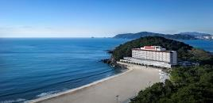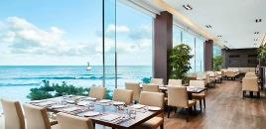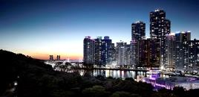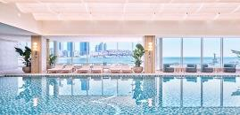
*Tel.
*E-mail
Bonvoy No.
2. Reservation Detail
*Check In (mm/dd/yy) |  |  |  |  |  | *Check Out (mm/dd/yy)
*Room Type  Random assignment of bed type |  |  | Special Rate |  |  | No. Rooms |  | Double  Occupancy | Others
Deluxe Park |  |  | ☐ KRW 266,200 |  |  |  |  | - | Breakfast(58,000KRW)  ☐ Y ☐ N  (Camellia Buffet / 06:30~10:00am at Lobby FL)
Deluxe Beach |  |  | ☐ KRW 302,500
Executive Park |  |  | ☐ KRW 338,800 |  |  |  |  | ☐ 60,500 | Westin Club Lounge incl.  (B/F, Daytime Snack, Happy Hour)
Executive Beach |  |  | ☐ KRW 375,100
- The above proposed special offer is applicable only during the period. (1st Jun to 5th Jun)
- Deluxe :Free access to swimming pool and fitness center/ 50% off sauna/2btls mineral water
- Executive :Free access to sauna and club lounge(Breakfast, Daytime Snack, Happy Hour ) /48,400 is applied for double occupancy.
- 10% Service Charge & 10% VAT are included. (5th Jun(Thu) / KRW 120,100 add)
- Check In: 15:00 PM / Check Out: 12:00 NOON
3. Payment
*Credit Card Number: |  |  |  | ☐ Etc. ☐ Visa ☐ Masters ☐ Amex (4Digit-number : )
*Expiry Date(mm/yy) |  |  |  |  | *Card Holder’s Name
4. Guarantee Rules and Cancellation Policy
- All reservations must to be guaranteed by credit card upon reservation
- Please advise of changes or cancellations by 6:00 PM(KST) 7 days prior to avoid 1 night penalty charge with Taxes

I have read and understood the guarantee rules and cancellation policy and wish to confirm hotel reservation as above.

DATE [mm/dd/yy] |  | PRINT NAME

